LaCie 16TB 2big Dock 2-Bay Thunderbolt 3 RAID Array (Black)

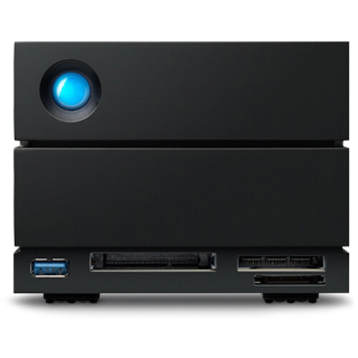

**Key Features**

* **16TB Total Storage Capacity**: With 16 terabytes of storage (using two 8TB hard drives), the LaCie 2big Dock provides ample space for storing and managing large video projects, photo libraries, design files, backups, and more.
* **Thunderbolt 3 Connectivity**: Equipped with Thunderbolt 3, the drive delivers ultra-fast data transfer speeds of up to **40Gbps**, making it ideal for video editing, 3D rendering, and high-performance workflows. It’s backward compatible with USB-C, but Thunderbolt 3 ensures the fastest possible data rates.
* **RAID 0 and RAID 1 Support**: The 2big Dock allows users to configure the drives in RAID 0 (striping) for enhanced performance or RAID 1 (mirroring) for data redundancy and protection against drive failure.

**Software and Compatibility**

* **LaCie Toolkit**: The LaCie Toolkit software helps you set up automatic backups, manage RAID configurations, and monitor the health of the drives, making it easier to manage your storage and data.

**Warranty and Support**

* **5-Year Limited Warranty**: The LaCie 2big Dock comes with a 5-year warranty, providing long-term peace of mind for professionals who rely on their storage solutions.
* **Rescue Data Recovery**: A one-year subscription to LaCie’s Rescue Data Recovery Service is included, which offers data recovery support in case of drive failure or accidental data loss.